**REAL ESTATE MANAGEMENT**

**Mini Project Report**

***Submitted by***

**Anuj Singh [RA1911003010832]**

**Rajmun Khan [RA1911003010826]**

**Het Soni[RA1911003010828]**

Course: 18CSC3003J Database Management Systems

**COLLEGE OF ENGINEERING AND TECHNOLOGY**

**\**



S.R.M. Nagar, Kattankulathur, Chengalpattu District

**May 2022**

1

**Declaration**

I/We declare that “**Real Estate Management**” is the bonafide work of **Rajmun Khan[RA1911003010826]**

**Anuj Singh[RA1911003010832].**

**Het Soni[RA1911003010828]**

**Signature of the students**

# Abstract

The real estate management system is programming implied for aiding foundations. A piece of programming helps run the management authoritative flawlessly from far off. The Real Estate management system features managing houses for buying and renting purposes. This system will provide facility to the user to search Residential and Commercial property and

view property. This system will provide facility to view the property by admin and user. User

will able to upload the property information to the site and able to manage it. This system will

provide facility to the user to fill up their requirement and according to their Requirement Admin

can add the Requirement property. This system will provide facility to the user to publish

advertise to the Site and view. This system will provide facility to the user to feedback to the site.

**TABLE OF CONTENTS**

|  | Abstract |
| --- | --- |
|  | Table of Contents |
| **1** | Introduction |
| **2** | Description of the aim/objective and applications of the  work and software used |
| **3** | Tables and Front end (if used) Screen shots |
| **4** | Conclusion and Future Work |
| **5** | References |
| **6** | Appendix |

# Introduction

Real estate event management system is a software that offers a platform for property buyers and sellers to locate properties of interest. It offers residential and commercial property listings for both sale and rent across the country.

People used to buy and sell houses in the local paper, or look for realtors in the phone book. But today they search online when they want to find a new home, compare property management companies or find a real estate agent to sell their house.

The real estate industry has witnessed high competition in the past few years due to the emergence of new technologies. Real estate builders, agents, and brokers need to transform their business strategies for delivering better services to their customers and earn higher profits.

Creating profiles on real estate systems and marketplaces is not enough to get business from the target audience. Here, we present top reasons why real estate builders, agents, and brokers need their own website.

# Objective:-

The real estate management system provides applications to facilitate the location of the nearest office to the user. Very important for a good connection between the online and offline environment. The “property finder” must be simple to use and very intuitive, in order to provide the user with a pleasant navigation and a positive search experience. Following the same line as the “Information & Education”, the website must show transparency to the user with the aim of increasing their confidence towards the brand, and for this the videos and customer opinions are a key factor.

For the clients it is the most important economic transaction of their life, a process that they have never done before and therefore they have many doubts. The website must provide valuable information on the entire purchase / sale process.The main objective is To manage, improve, develop, hold or acquire by purchase, lease, exchange or otherwise and to sell, alienate, dispose of lands, estates, buildings, easements, hereditaments, flats, garages, houses, halls, godowns, mills, tenements, factories, chawls, dwelling houses or other landed properties of any tenure or description and any estate or interest therein or rights connected therewith and to turn the same to accounts as may be expedient and in particular by laying out and preparing building sites by planting, paving, draining and cultivating land and by demolishing, constructing and reconstructing properties by leasing or otherwise and disposing the same.

# Aim

To create user-friendly software to provide information and manage any real estate problem efficiently

## Languages used

HTML, MySQL, CSS, PHP

## Software used

VS Code, XAMPP, phpMyAdmin

# ER DIAGRAM:

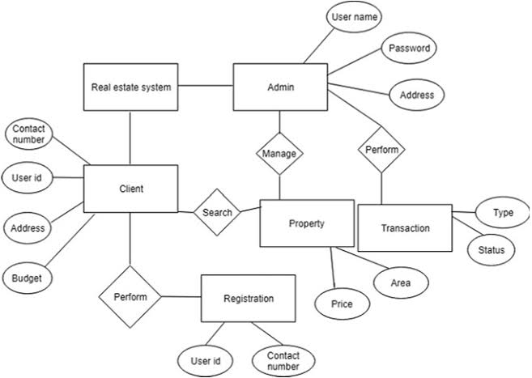

# MODULES:

**Admin Module**

Dashboard: In this section, admin can see all detail in brief like total property type, total country, total state, total city, total agent, total owner, total buyer(user) ant total property listed.

Property Type: In this section, the admin can manage property type (add/update).

Country: In this section, admin can manage country (add/update).

State: In this section, admin can manage state (add/update).

City: In this section, the admin can manage city (add/update).

Owner: In this section, admin can view the detail of the owners.

Agents: In this section, admin can view the detail of agents.

User: In this section, admin can view the detail of the user.

List of properties: In this section, admin can view details of the property listed,

Reviews: In this section admin, can view reviews and also approved, disapproved and delete the reviews which is given by users.

Pages: In this section, the admin can manage about us and contact us pages.

Search Property: In this section admin, can search the listed property by its property id, name and mobile number.

Admin can also update his profile, change the password and recover the password.

**User Module**

Property Owner

Home Page: Owner can view the home page of the real estate management system

About: Owner can view about us page.

Properties: Owner can view own and other owner properties they can view property type wise, Status wise and city wise.

Contact us: Owner can view contact us page.

My Account: In this, there is three sections: (A) User Profile

In this section, the owner do the following activity

Edit Profile: Owner can edit his/her own profile.

Change Password: Owner can change his/her own password.

Add Property: Owner can add his/her own property

My Properties: Owner can see his/her own listed properties.

Received Enquiries: Owner can view receive enquiries against his/her own listed properties and also answer the enquiries.

Answer Enquiries: Owner can view answer enquiries.

Logout: Owner can logout from own account.

(B)Change Password: Owner can change his/her own password.

(C)Logout: Owner can logout from own account.

**Brokers / Agents**

Home Page: Agents can view the home page of the real estate management system.

About: Agents can view about us page.

Properties: Agents can view own and other owner properties they can view property type wise, Status wise and city wise.

Contact us: Agents can view contact us page.

My Account: In this, there are three sections: (A)User Profile

In this section, Agents do the following activity

Edit Profile: Agents can edit his/her own profile.

Change Password: Agents can change his/her own password.

Add Property: Agents can add his/her own property.

My Properties: Agents can see his/her own listed properties.

Received Enquiries: Agents can view receive enquiries against his/her own listed properties and also answer the enquiries.

Answer Enquiries: Agents can view answer enquiries.

Logout: Agents can logout from own account.

(B)Change Password: Agents can change his/her own password.

(C)Logout: Agents can logout from own account.

**Buyer(simple user)**

Home Page: User can view the home page of the real estate management system

About: User can view about us page.

Properties: User can view properties they can view property type wise, Status wise and city wise and put his/her enquiries against any property

Contact us: User can view contact us page.

My Account: In this, there is three sections: (A)User Profile

In this section, Agents do the following activity

Edit Profile: Agents can edit his/her own profile.

Change Password: Agents can change his/her own password.

Logout: Agents can logout from own account.

(B).Change Password: Agents can change his/her own password.

(C).Logout: Agents can logout from own account.

# FRONT END:

# 

# 

# 

# TABLES :

# 

# 

# 

# 

# 

# 

**Conclusion**

The real estate management system was completed and demonstrated successfully.

# Future Work

In the future, we would like to work more on the ML part of the software. We will be adding a messaging software that would send information via SMS and receive SMS. We would like to try and deploy this application on the cloud so that it can be used in real-life situations.

**References** https://[www.w3schools.com/php/php_mysql_create.asp](http://www.w3schools.com/php/php_mysql_create.asp) https://[www.w3schools.com/html/html_form_attributes_form.asp](http://www.w3schools.com/html/html_form_attributes_form.asp) https://[www.w3schools.com/mySQl/mysql_primarykey.asp](http://www.w3schools.com/mySQl/mysql_primarykey.asp)